

**Superior University Lahore**

**Name: Ahsan Ali**

**Roll no: 061**

**Subject: Programming for AI**

**Task: 4**

**Submitted To: Sir Rasikh**

**N-Queens Problem**

**Problem Explanation:**

The N-Queens problem is a classic algorithmic problem in which the challenge is to place N chess queens on an N x N chessboard such that no two queens threaten each other. A queen can attack another queen if they are in the same column, row or diagonal. The objective is to find a solution where all N queens can be safely placed on the board.

**Code Explanation:**

The Safe function checks if a queen can be safely placed on the board at a given position. It checks if any queens exist in the same column or diagonals.

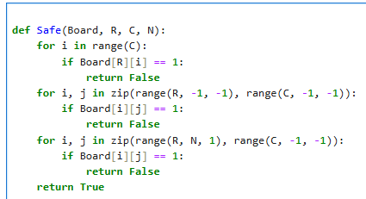

The **SolveQ** function attempts to place queens in a column. If it reaches the end of the board, it means all queens have been placed. If placing a queen in a row doesn't lead to a solution, it backtracks and tries the next possibility.

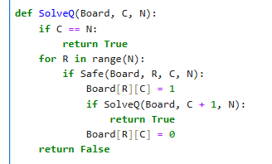

The **nQueens** function initializes the board and calls the **SolveQ** function to start solving the N-Queens problem. If a solution is found, it prints the board with queens placed.

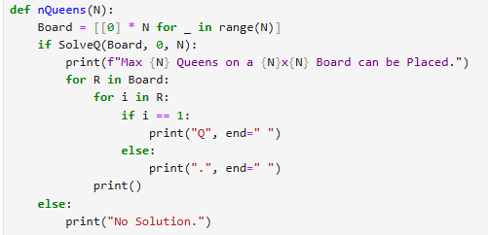

The code takes user input for the board size and calls the **nQueens** function to attempt to solve the problem.

C:\Users\SANDHU PC\Pictures\PAI Task 3(SS4).png

**Output:**

